**Experiment Number - 3**

**Student Name:** ANIKET KUMAR **UID:** 20BCS5306

**Branch:** CSE **Section/Group:** 20BCS_WM-703 / B

**Semester:** 5th **Date of Performance:** 23rd Aug, 2022

**Subject Name:** PBLJ LAB **Subject Code:** 20CSP-321

**1. Aim/Overview of the practical:** Create an application to calculate interest for FDs, RDs based on certain conditions using inheritance.

**2. Task to be done/ Which logistics used:**

IntelliJ IDEA (IDE), JDK.

**3. Program Code:**

import java.util.Scanner;

abstract class Account {

double interestRate, amount;

abstract double calculateInterest();

}

class MyException extends Exception {

public MyException() {

System.out.println("Invalid input!!");

System.exit(0);

}

}

class FDAccount extends Account {

Scanner sc = new Scanner(System.in);

double interestRate, amount;

int days, age = 0;

void input() {

try {

System.out.println("Enter amount (in Rs): ");

amount = sc.nextInt();

if (amount < 0) throw new MyException();

System.out.println("Enter maturity period (in days): ");

days = sc.nextInt();

if (days < 0) throw new MyException();

if (amount < 10000000) {

System.out.println("Enter age (in years): ");

age = sc.nextInt();

if (age < 0) throw new MyException();

}

} catch (MyException ex) {

}

}

double calculateInterest() {

double interest = 0;

if (age != 0) {

if (age > 60) {

if (days >= 7 && days <= 14) interestRate = 5.00;

else if (days >= 15 && days <= 29) interestRate = 5.25;

else if (days >= 30 && days <= 45) interestRate = 6.00;

else if (days >= 46 && days <= 60) interestRate = 7.50;

else if (days >= 61 && days <= 184) interestRate = 8.00;

else if (days >= 185 && days <= 365) interestRate = 8.50;

else {

interestRate = 0;

System.out.println("Invalid maturity period");

}

} else {

if (days >= 7 && days <= 14) interestRate = 4.50;

else if (days >= 15 && days <= 29) interestRate = 4.75;

else if (days >= 30 && days <= 45) interestRate = 5.50;

else if (days >= 46 && days <= 60) interestRate = 7.00;

else if (days >= 61 && days <= 184) interestRate = 7.50;

else if (days >= 185 && days <= 365) interestRate = 8.00;

else {

interestRate = 0;

System.out.println("Invalid maturity period");

}

}

} else {

if (days >= 7 && days <= 14) interestRate = 6.50;

else if (days >= 15 && days <= 29) interestRate = 6.75;

else if (days >= 30 && days <= 45) interestRate = 6.75;

else if (days >= 46 && days <= 60) interestRate = 8.00;

else if (days >= 61 && days <= 184) interestRate = 8.50;

else if (days >= 185 && days <= 365) interestRate = 10.00;

else {

interestRate = 0;

System.out.println("Invalid maturity period");

}

}

interest = (interestRate * amount) / 100;

return interest;

}

}

class RDAccount extends Account {

Scanner sc = new Scanner(System.in);

double interestRate, amount;

int months, age = 0;

void input() {

try {

System.out.println("Enter amount (in Rs): ");

amount = sc.nextInt();

if (amount < 0) throw new MyException();

System.out.println("Enter maturity period (in months): ");

months = sc.nextInt();

if (months < 0) throw new MyException();

System.out.println("Enter age (in years): ");

age = sc.nextInt();

if (age < 0) throw new MyException();

} catch (MyException ex) {

}

}

double calculateInterest() {

double interest = 0;

if (age > 60) {

if (months == 6) interestRate = 8.00;

else if (months == 9) interestRate = 8.25;

else if (months == 12) interestRate = 8.50;

else if (months == 15) interestRate = 8.75;

else if (months == 18) interestRate = 9.00;

else if (months == 21) interestRate = 9.25;

else {

interestRate = 0;

System.out.println("Invalid maturity period");

}

} else {

if (months == 6) interestRate = 7.50;

else if (months == 9) interestRate = 7.75;

else if (months == 12) interestRate = 8.00;

else if (months == 15) interestRate = 8.25;

else if (months == 18) interestRate = 8.50;

else if (months == 21) interestRate = 8.75;

else {

interestRate = 0;

System.out.println("Invalid maturity period");

}

}

interest = (interestRate * amount) / 100;

return interest;

}

}

class SBAccount extends Account {

String type;

void input() {

try {

Scanner sc = new Scanner(System.in);

System.out.println("Enter amount (in Rs): ");

amount = sc.nextInt();

if (amount < 0) {

throw new MyException();

}

System.out.println("enter the type of account:-(NRI/Normal) ");

type = sc.next();

} catch (MyException ex) {

}

}

double calculateInterest() {

if (type.equalsIgnoreCase("NRI")) interestRate = 6.0;

else interestRate = 4.0;

double interest = (interestRate * amount) / 100;

return interest;

}

}

public class Main {

public static void main(String[] args) {

Scanner sc = new Scanner(System.in);

int c;

double result;

while (true) {

System.out.println("0. Exit\n" +

"1. SB\n" +

"2. FD\n" +

"3. RD\n" +

"Enter your choice:");

c = sc.nextInt();

switch (c) {

case 0:

System.exit(0);

case 1:

SBAccount sb = new SBAccount();

sb.input();

result = sb.calculateInterest();

System.out.println("Interest is " + result);

break;

case 2:

FDAccount fd = new FDAccount();

fd.input();

result = fd.calculateInterest();

System.out.println("Interest is " + result);

break;

case 3:

RDAccount rd = new RDAccount();

rd.input();

result = rd.calculateInterest();

System.out.println("Interest is " + result);

break;

}

}

}

}

**4. Output :**

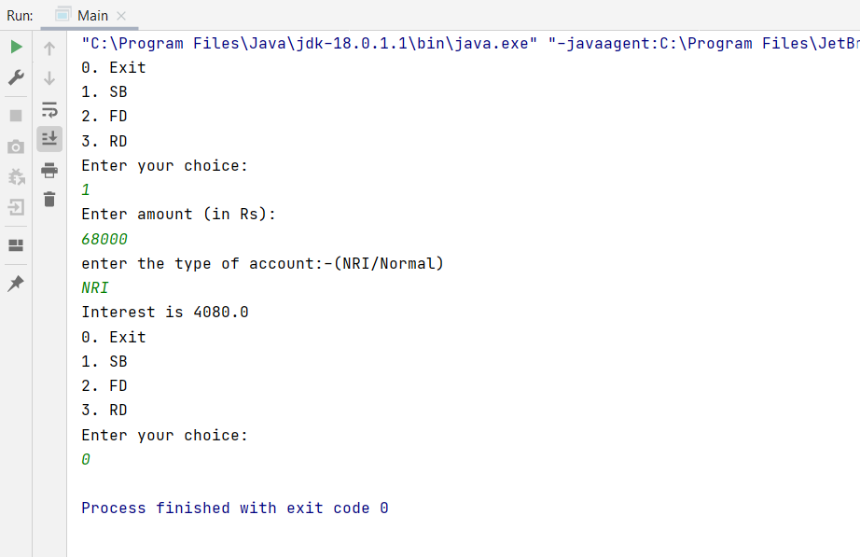

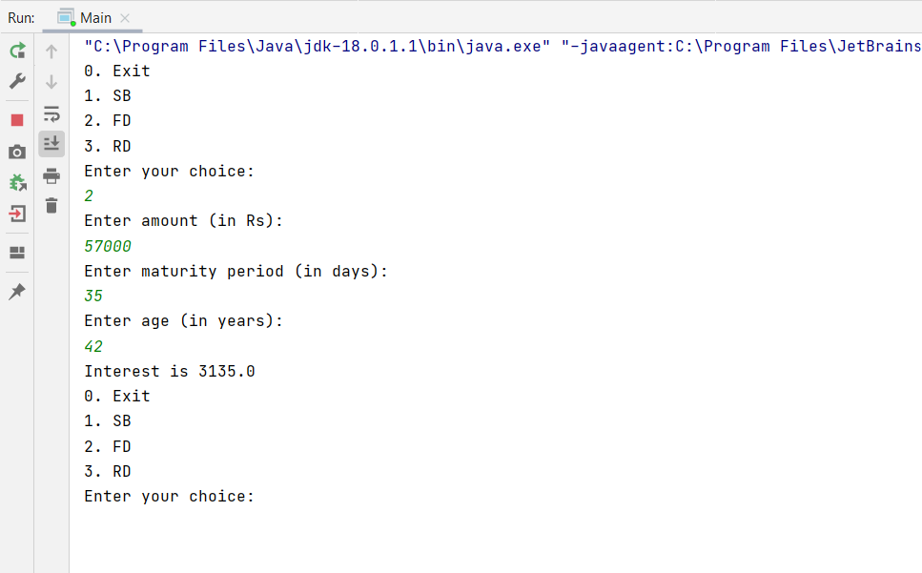

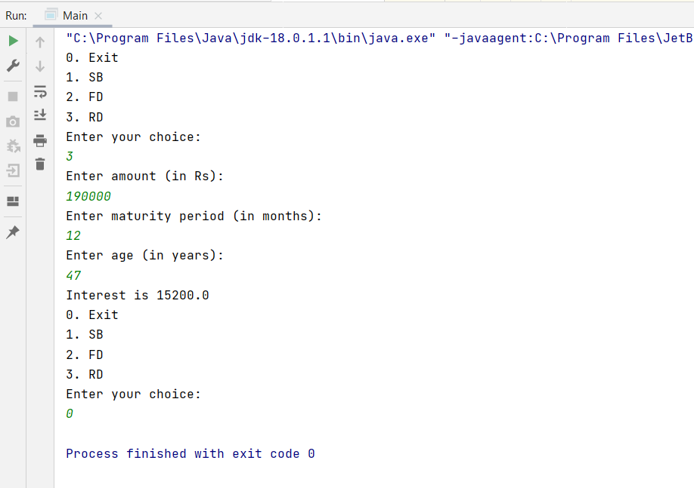

**Learning outcomes (What I have learnt):**

1. I have learnt how to write program in JAVA.
2. I have learnt how to create classes and its objects in JAVA.
3. I have learnt how to take input from user using Scanner class.
4. I have learnt how to create Array in JAVA and traverse each elements using loop.
5. I have learnt how to create an application to calculate interest for FDs, RDs based on certain conditions using inheritance in JAVA.

**Evaluation Grid (To be created as per the SOP and Assessment guidelines by the faculty):**

|  |  |  |  |
| --- | --- | --- | --- |
| Sr. No. | Parameters | Marks Obtained | Maximum Marks |
| 1. |  |  |  |
| 2. |  |  |  |
| 3. |  |  |  |
|  |  |  |  |